Code
function sum(a){
var tSum = 0;
for(var i=0; i<a.length; i++){
tSum = tSum + a[i];
}
return tSum;
}

const a = [1,2,3,4,5];
console.log("The sum of array is: ", sum(a));
console.log("The total sum of array elements is: ", sum2(a));

function sum2(array){
var totalSum = 0;
for(var num of array){
totalSum += num;
}
return totalSum;
}

Output

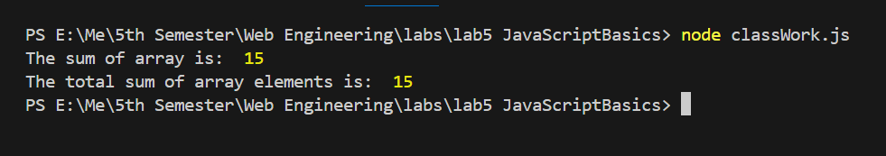

Code

const course = "Web Engineering";

console.log(course);

//const course = "Other"; This cause an error because 'course' has already been declared with 'const'
console.log(course);

const count = 0;
// count += 1; this also causes an error because 'count' is a constant and cannot be reassigned

console.log(0 == false); // true because 0 is falsy
console.log(0 === false); // false because they are of different types
console.log([] == false); // true because [] is falsy

Output
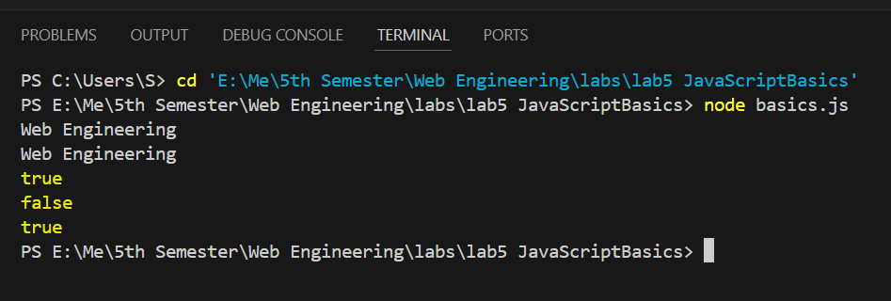

Code

function getInitials(name){
const names = name.split(' ');
let initials = '';

for(let i=0; i<names.length; i++){
initials += names[i].charAt(0);
}
return initials;
}

function isPalindrome(str){
// Remove space for accurate comparison
str = str.replace(/\s/g, '').toLowerCase();
const reversedStr = str.split('').reverse().join('');
return str === reversedStr;
}

function countWords(str){
const words = str.split(' ');
return words.length;
}

const name = "Abdul Manan";
console.log("The initials of the name are: ", getInitials(name))
console.log("Is the \"Madam\" a palindrome? ", isPalindrome("Madam"));
console.log("Is the \"Race car\" a palindrome? ", isPalindrome("Race car"));
console.log("The number of words in the string is: ", countWords("This is a sample string for counting words."));

Output


